JUnit Testing Exercises
Exercise 1: Setting Up Junit
Program: Calculator.java
public class Calculator {
public int add(int a, int b) {
return a + b;
}
}
Program: JunitTestClass
CalculatorTest.java
import static org.junit.Assert.*;
import org.junit.Test;

public class CalculatorTest {

Calculator calc = new Calculator();

@Test
public void testAdd() {
int result = calc.add(5, 5);
System.out.println("Testing Addition: 5 + 5 = " + result);
assertEquals(10, result);
}
}

OUTPUT:

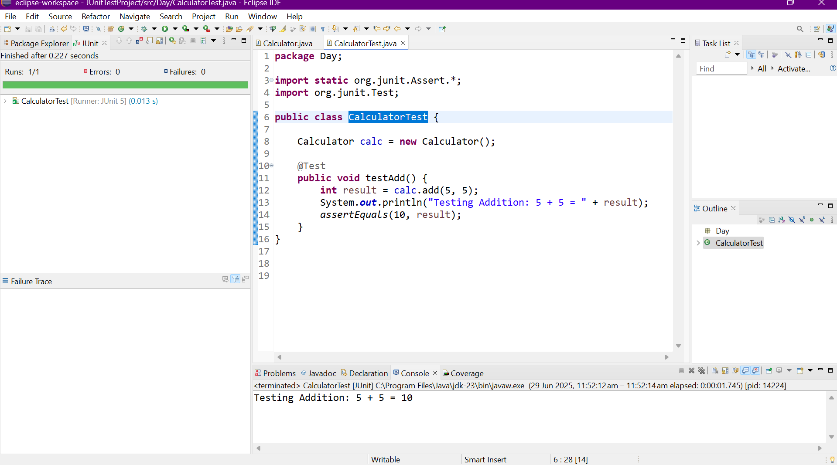

Exercise 3: Assertions in Junit
Program:
import org.junit.Test;
import static org.junit.Assert.*;

public class MyLogicTest {

MyLogic logic = new MyLogic();

@Test
public void testAllAssertions() {
// 1. assertEquals
assertEquals(10, logic.add(7, 3));

// 2. assertTrue
assertTrue(logic.isPositive(5));

// 3. assertFalse
assertFalse(logic.isPositive(-1));

// 4. assertNull
assertNull(logic.returnNull());

// 5. assertNotNull
assertNotNull(logic.returnObject());

// 6. assertEquals with strings
assertEquals("JUnit", logic.echo("JUnit"));

// 7. assertTrue with string logic
assertTrue(logic.echo("hello").startsWith("h"));

// 8. assertFalse with empty string check
assertFalse(logic.isStringEmpty("Not Empty"));

// 9. assertSame
Integer x = 100;
assertSame(x, logic.sameReference(x));

// 10. assertNotSame
assertNotSame(new String("a"), new String("a"));
}
}
Output:

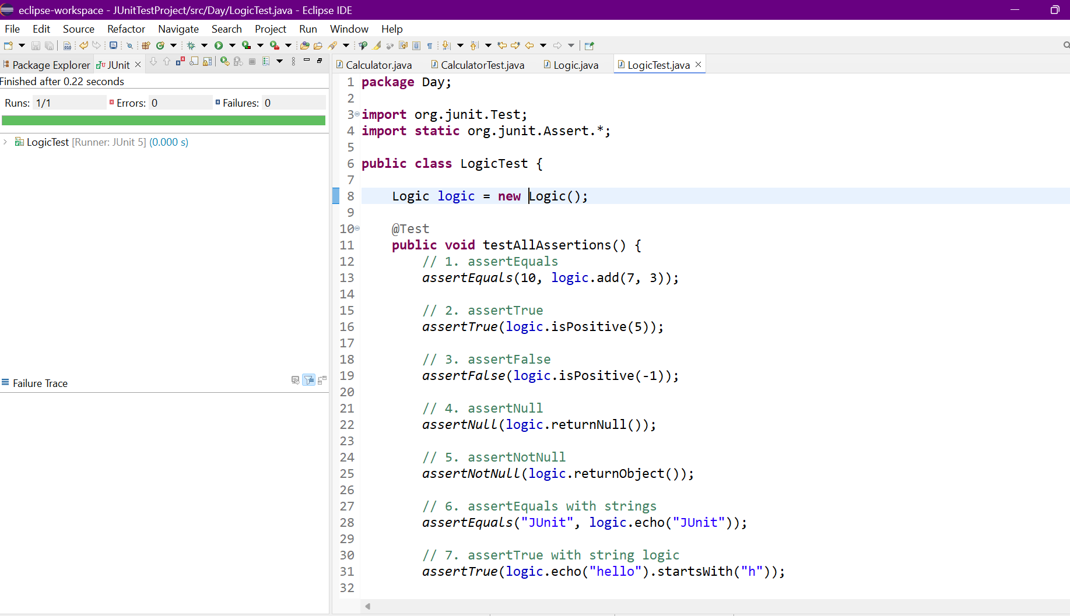

Exercise 4: Arrange-Act-Assert (AAA) Pattern, Test Fixtures, Setup and Teardown Methods in Junit
Program:
Calculator.java;
public class Calculator {
public int add(int a, int b) {
return a + b;
}

public int subtract(int a, int b) {
return a - b;
}

public int multiply(int a, int b) {
return a * b;
}

public int divide(int a, int b) {
if (b == 0) throw new ArithmeticException("Divide by zero");
return a / b;
}
}
CalculatorTest.java:
Program:
import org.junit.After;
import org.junit.Before;
import org.junit.Test;
import static org.junit.Assert.*;

public class CalculatorTest {

private Calculator calculator;

// Setup method runs before each test
@Before
public void setUp() {
calculator = new Calculator();
System.out.println("Setup: New Calculator created");
}

// Teardown method runs after each test
@After
public void tearDown() {
System.out.println("Teardown: Test complete\n");
}

@Test
public void testAddition() {
// Arrange
int a = 5, b = 3;

// Act
int result = calculator.add(a, b);

// Assert
assertEquals(8, result);
}

@Test
public void testSubtraction() {
// Arrange
int a = 10, b = 4;

// Act
int result = calculator.subtract(a, b);

// Assert
assertEquals(6, result);
}

@Test
public void testMultiplication() {
// Arrange
int a = 6, b = 7;

// Act
int result = calculator.multiply(a, b);

// Assert
assertEquals(42, result);
}

@Test
public void testDivision() {
// Arrange
int a = 20, b = 5;

// Act
int result = calculator.divide(a, b);

// Assert
assertEquals(4, result);
}

@Test(expected = ArithmeticException.class)
public void testDivideByZero() {
// Arrange
int a = 10, b = 0;

// Act
calculator.divide(a, b);
// Assert handled by @Test(expected = ...)
}
}
OUTPUT:
